Open Convex-Looking Polygonal Chain
# Source: AI Source: Provided by: [Data Path: Persons Table -> ID Column: 1, Name_En Column: Motasem Essam] -> From: [ChatGPT] on [7/25/2026]
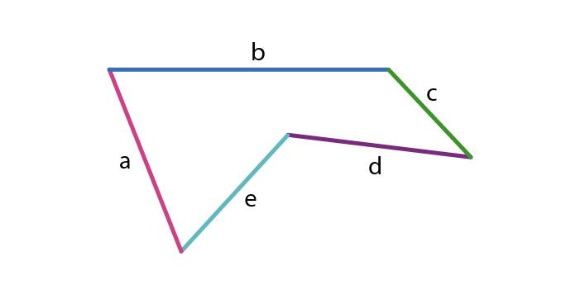
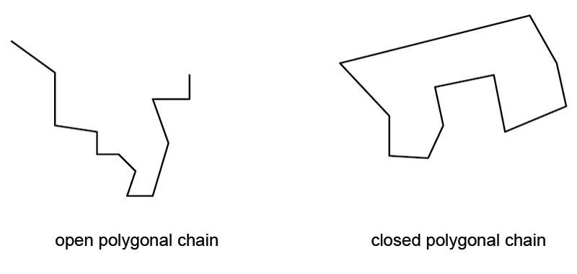
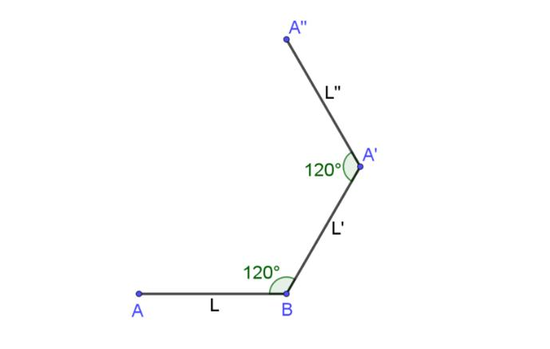

Definition
# Source: AI Source: Provided by: [Data Path: Persons Table -> ID Column: 1, Name_En Column: Motasem Essam] -> From: [ChatGPT] on [7/25/2026]
An Open Convex-Looking Polygonal Chain is an open chain of three or more connected straight-line segments that generally turns outward in one consistent direction, giving the overall chain a shape that visually resembles part of a convex polygon.
[
\boxed{
\text{Open Convex-Looking Polygonal Chain}
\text{Straight Segments}
+
\text{Consistent Outward Turning}
+
\text{Open Boundary}
}
]
Terminology note: In strict geometry, convexity applies to closed sets or polygons. An open chain is therefore more precisely described as convex-looking or an outward-turning polygonal chain, rather than a convex polygon.

Characteristics
# Source: AI Source: Provided by: [Data Path: Persons Table -> ID Column: 1, Name_En Column: Motasem Essam] -> From: [ChatGPT] on [7/25/2026]
An Open Convex-Looking Polygonal Chain:
- Is open.
- Contains three or more straight segments.
- Has connected consecutive segments.
- Has two unconnected endpoints.
- Does not enclose an area.
- Generally turns in the same rotational direction.
- Does not contain obvious inward indentations.
- Can be regular-looking or irregular.
- Can have equal or unequal segment lengths.
- Can be symmetric or asymmetric.
A simple representation is:
[
\boxed{
A\rightarrow B\rightarrow C\rightarrow D\rightarrow E
}
]
where the chain continually bends outward rather than creating an inward notch.

Types of Open Convex-Looking Polygonal Chains

1. Simple Open Convex-Looking Chain
# Source: AI Source: Provided by: [Data Path: Persons Table -> ID Column: 1, Name_En Column: Motasem Essam] -> From: [ChatGPT] on [7/25/2026]
A basic chain that bends consistently outward without self-intersection.
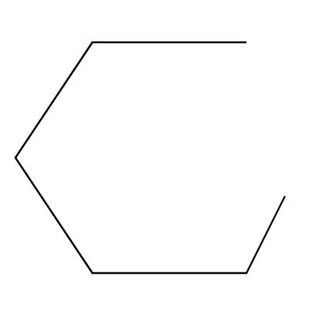
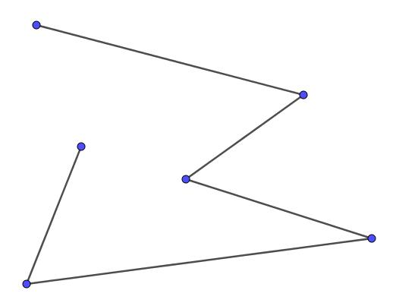
This is the basic form of the category.

2. Open Smoothly Turning Polygonal Chain
# Source: AI Source: Provided by: [Data Path: Persons Table -> ID Column: 1, Name_En Column: Motasem Essam] -> From: [ChatGPT] on [7/25/2026]
The segments change direction gradually, producing a visually smooth overall turn.
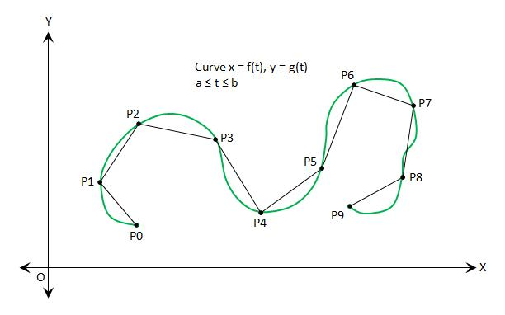
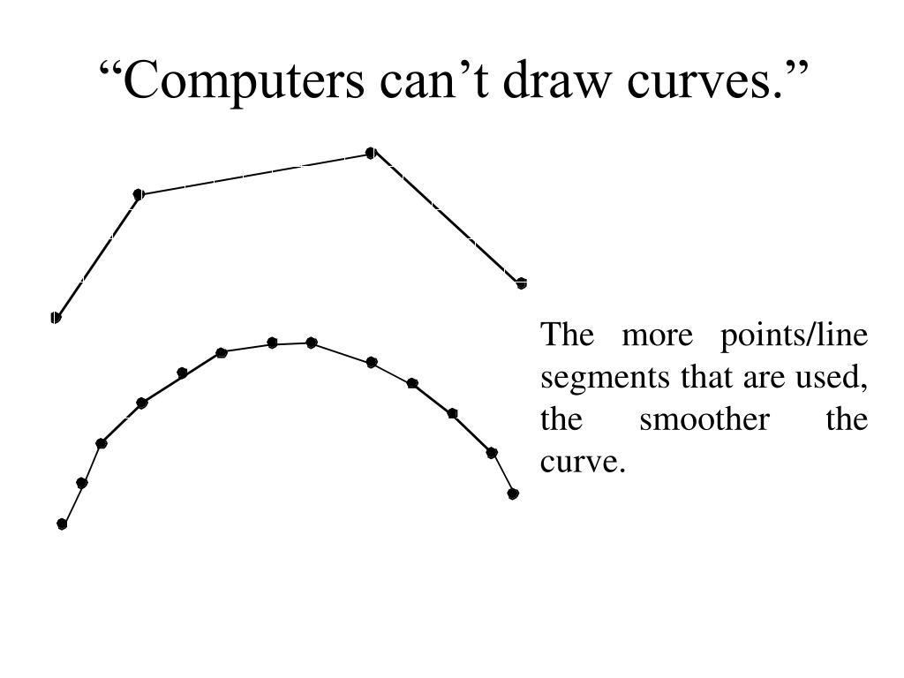
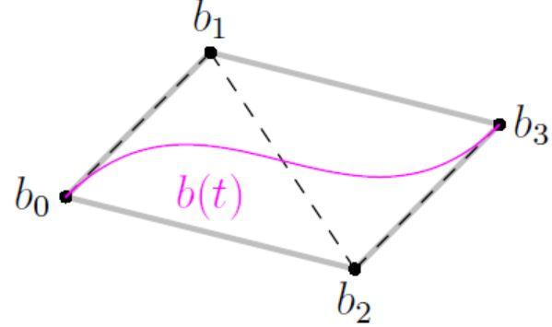
Each segment is still straight; the overall appearance comes from many small changes in direction.

3. Open Arc-Like Polygonal Chain
# Source: AI Source: Provided by: [Data Path: Persons Table -> ID Column: 1, Name_En Column: Motasem Essam] -> From: [ChatGPT] on [7/25/2026]
The segments approximate part of a circular or curved arc.
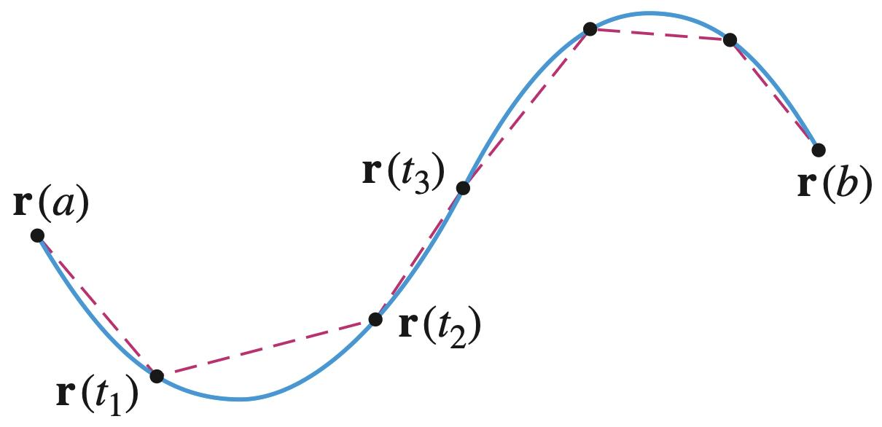
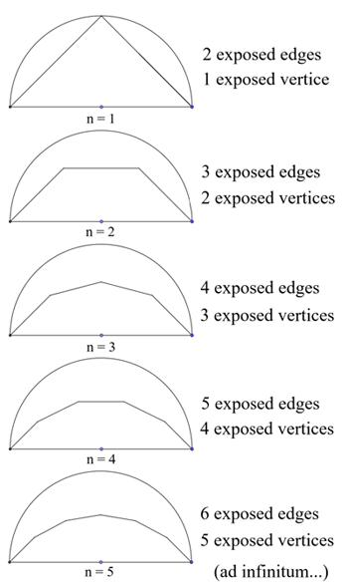
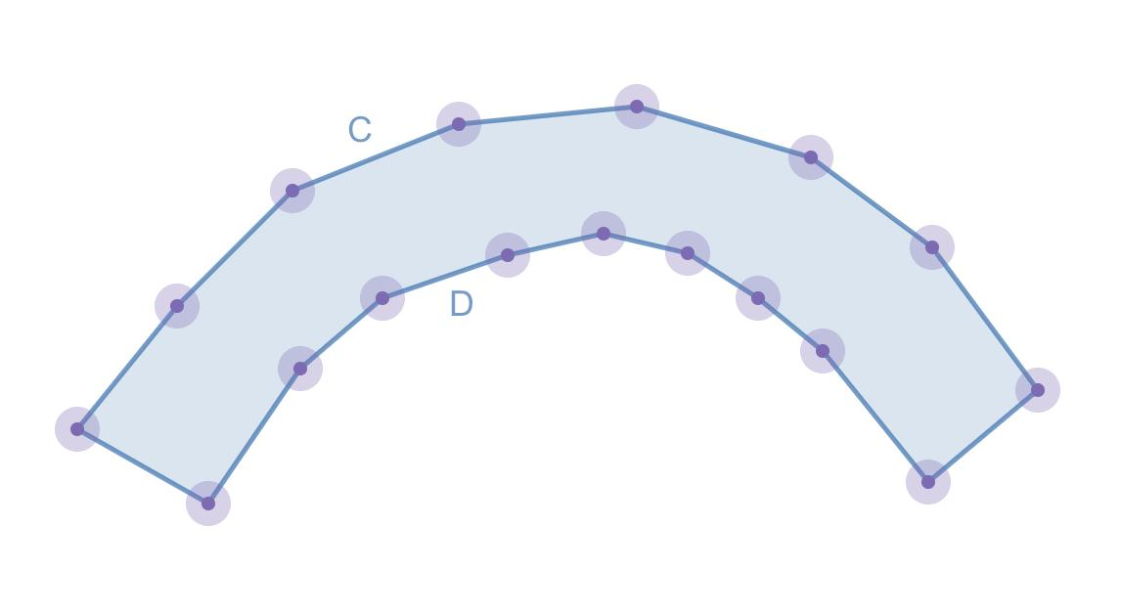
With sufficiently many short segments, the chain can visually approximate part of a curve.

4. Open Convex-Looking Zigzag Chain
# Source: AI Source: Provided by: [Data Path: Persons Table -> ID Column: 1, Name_En Column: Motasem Essam] -> From: [ChatGPT] on [7/25/2026]
The chain has visible direction changes but generally maintains an outward-turning structure.
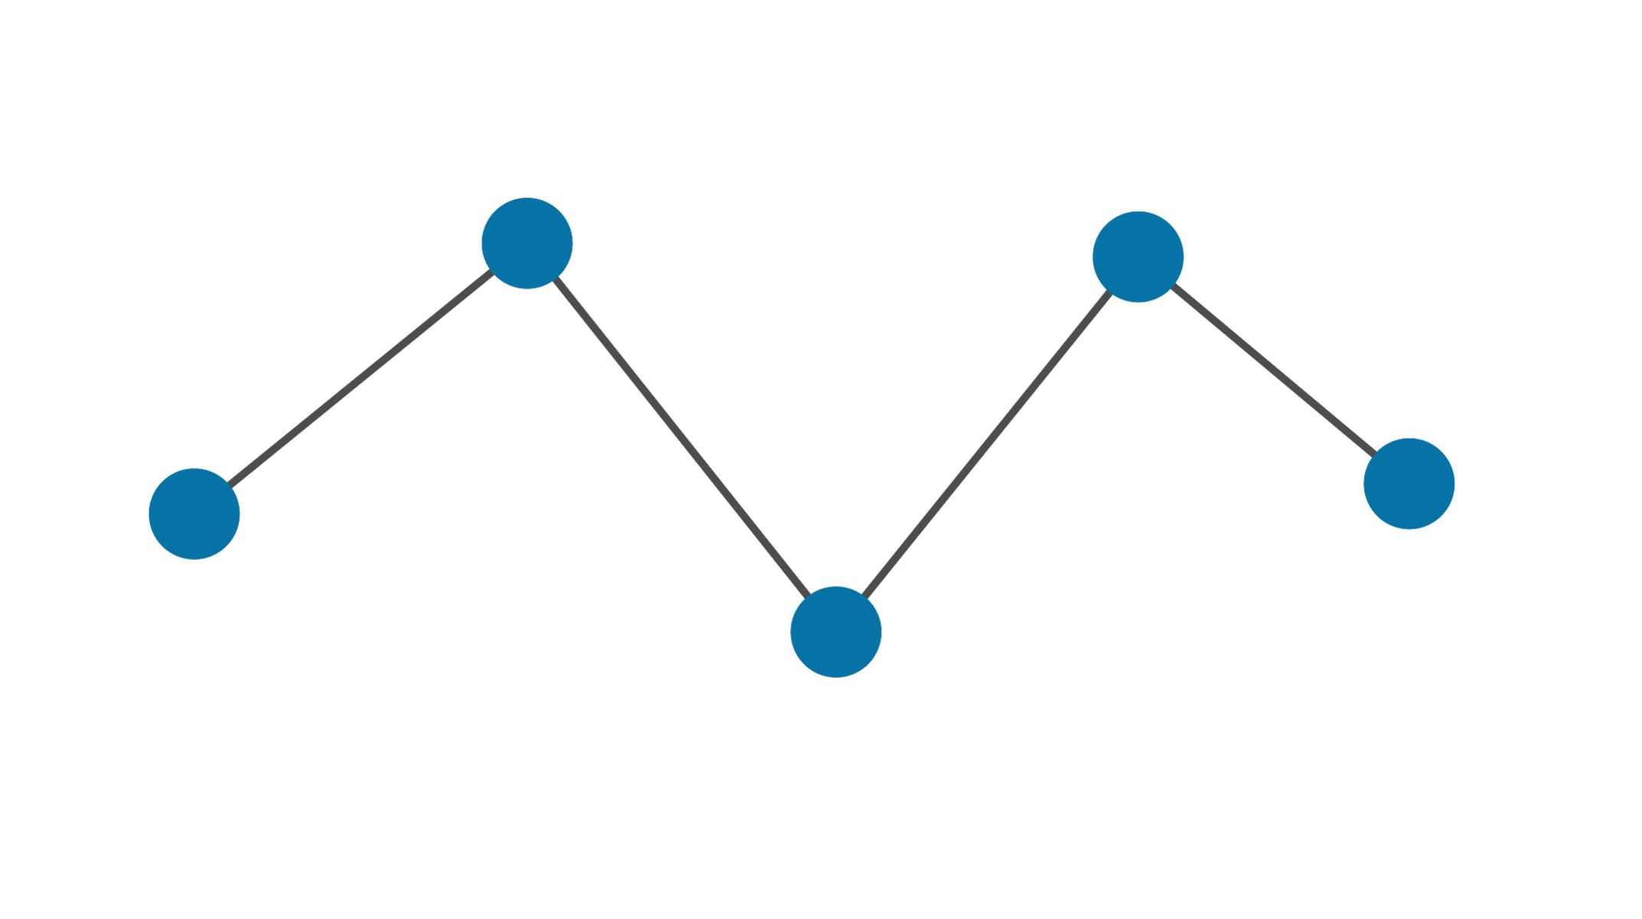
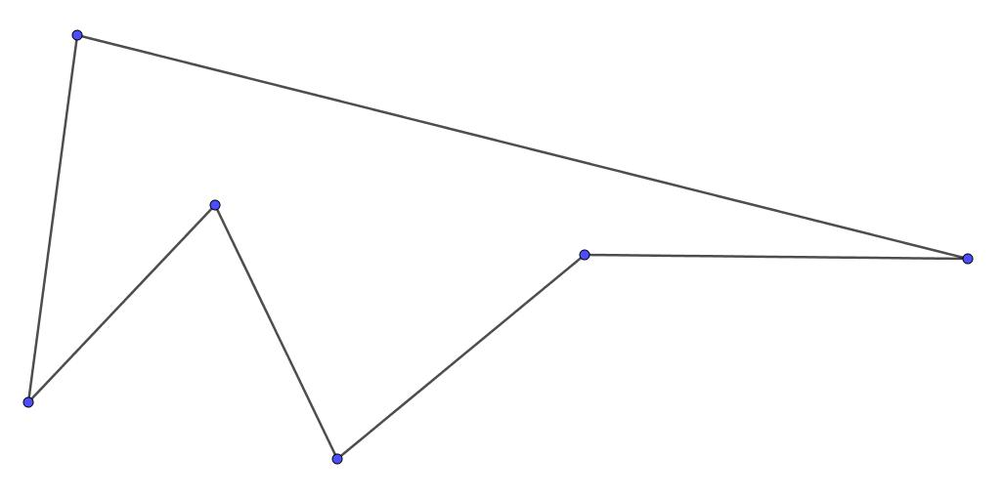
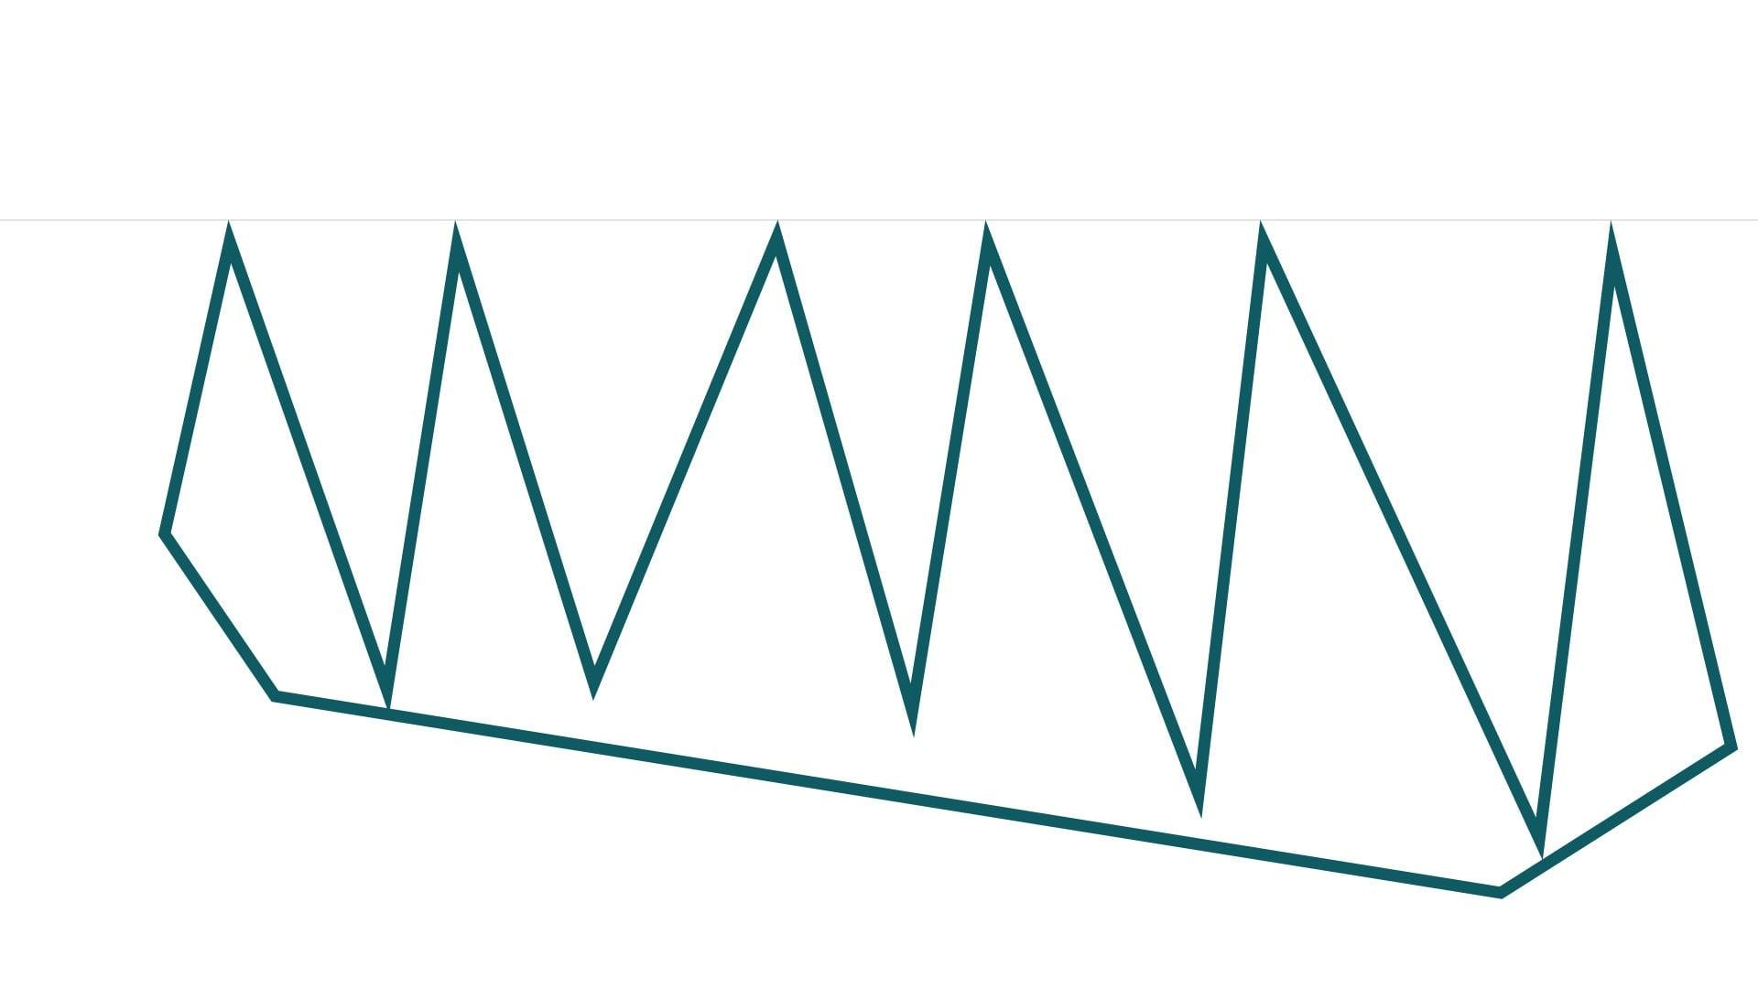
The zigzag pattern should not create a strong inward indentation.

5. Open Convex-Looking Stair-Step Chain
# Source: AI Source: Provided by: [Data Path: Persons Table -> ID Column: 1, Name_En Column: Motasem Essam] -> From: [ChatGPT] on [7/25/2026]
A horizontal/vertical chain that generally progresses around one side of an imaginary convex region.
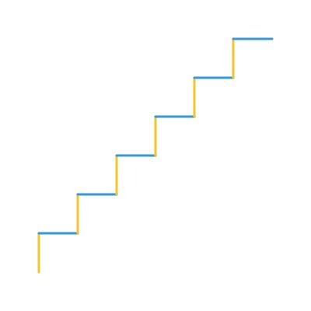
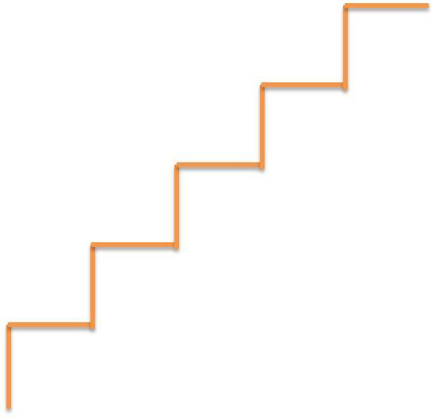
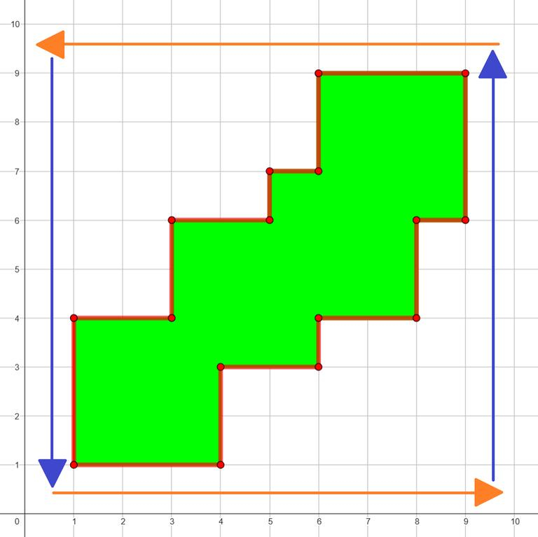
This is a rectilinear subtype.

6. Symmetric Open Convex-Looking Chain
# Source: AI Source: Provided by: [Data Path: Persons Table -> ID Column: 1, Name_En Column: Motasem Essam] -> From: [ChatGPT] on [7/25/2026]
The chain has an axis of symmetry while remaining open.
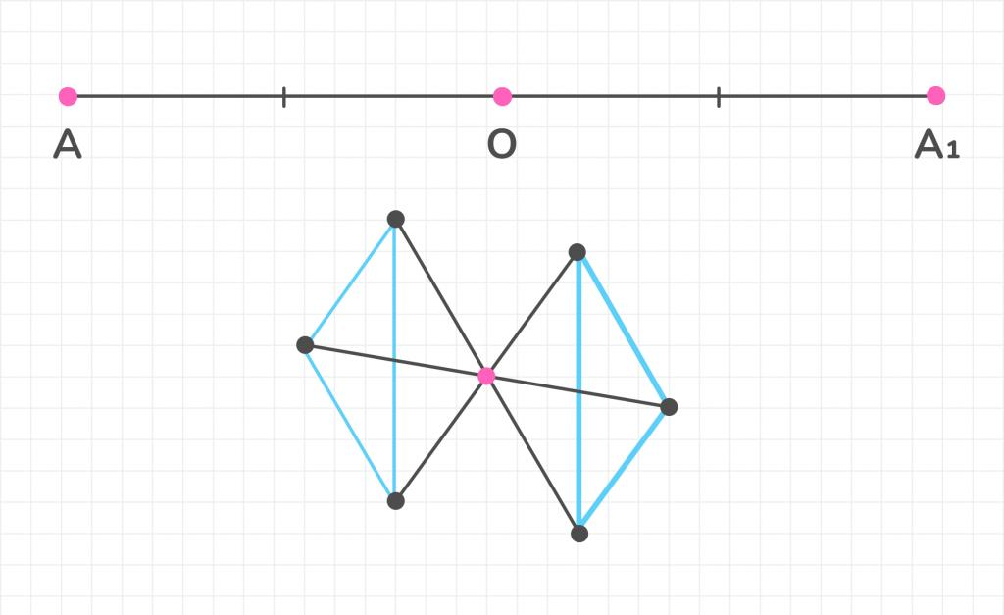
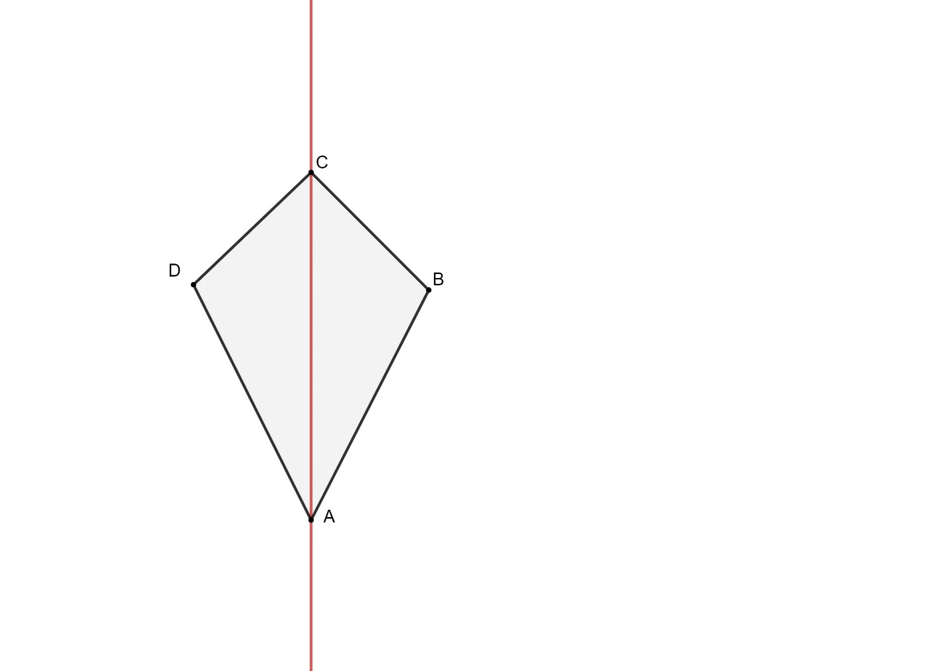
For example, the two halves may mirror one another about a vertical axis.

7. Asymmetric Open Convex-Looking Chain
# Source: AI Source: Provided by: [Data Path: Persons Table -> ID Column: 1, Name_En Column: Motasem Essam] -> From: [ChatGPT] on [7/25/2026]
The chain generally turns outward but has no regular symmetry.
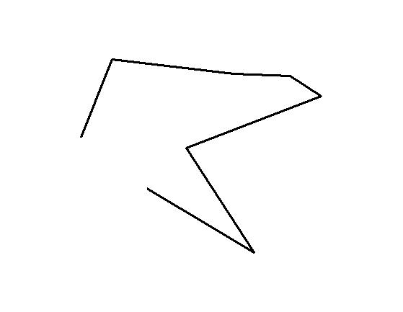
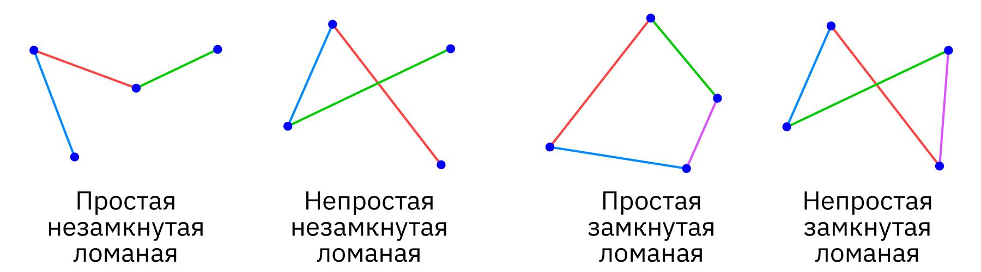
The segments can have different lengths and different turning angles.

8. Equal-Segment Open Convex-Looking Chain
# Source: AI Source: Provided by: [Data Path: Persons Table -> ID Column: 1, Name_En Column: Motasem Essam] -> From: [ChatGPT] on [7/25/2026]
All or most segments have equal lengths.
$$\boxed{L_{1}=L_{2}=L_{3}=⋯}$$
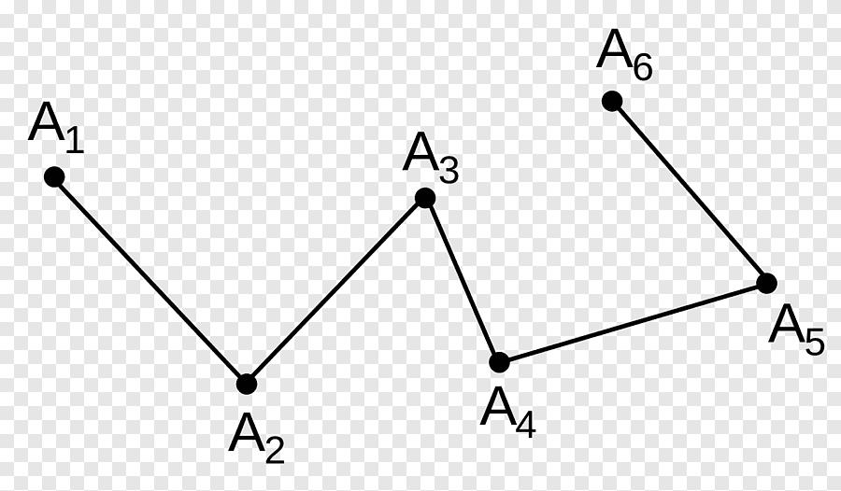
Equal lengths do not make the chain a closed polygon.

9. Unequal-Segment Open Convex-Looking Chain
# Source: AI Source: Provided by: [Data Path: Persons Table -> ID Column: 1, Name_En Column: Motasem Essam] -> From: [ChatGPT] on [7/25/2026]
The segments have different lengths while the overall chain maintains an outward-turning appearance.
$$\boxed{L_{1}≠L_{2}≠L_{3}≠⋯}$$
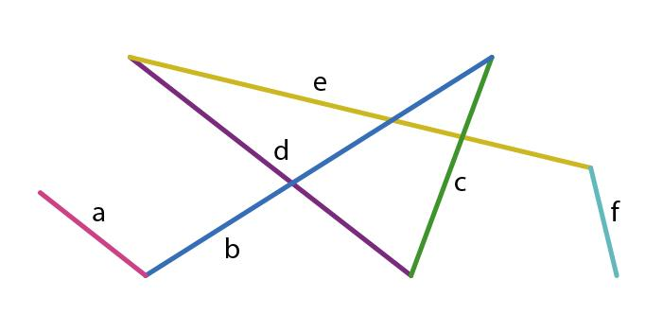

10. Open Convex-Looking Self-Intersecting Chain
# Source: AI Source: Provided by: [Data Path: Persons Table -> ID Column: 1, Name_En Column: Motasem Essam] -> From: [ChatGPT] on [7/25/2026]
A chain can visually suggest an outward pattern but contain segment crossings.
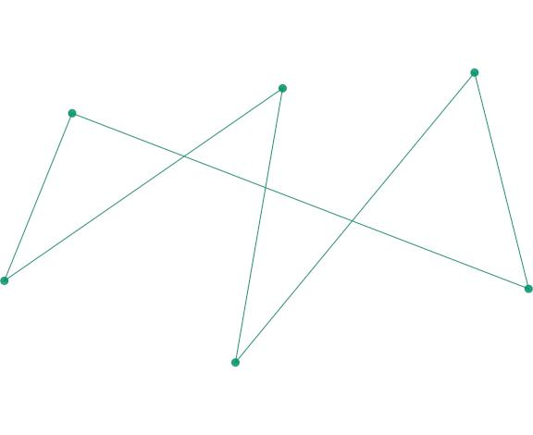
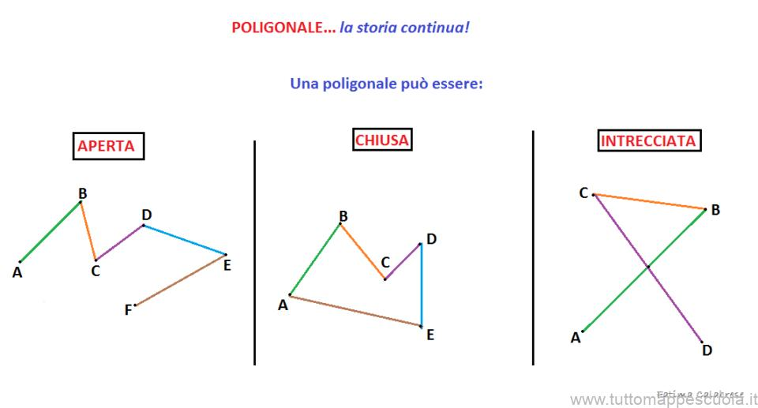
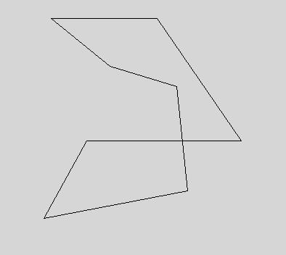
However, once substantial self-intersection occurs, describing the chain as convex-looking becomes less useful.

Convex-Looking vs. Concave-Looking Open Chains
# Source: AI Source: Provided by: [Data Path: Persons Table -> ID Column: 1, Name_En Column: Motasem Essam] -> From: [ChatGPT] on [7/25/2026]
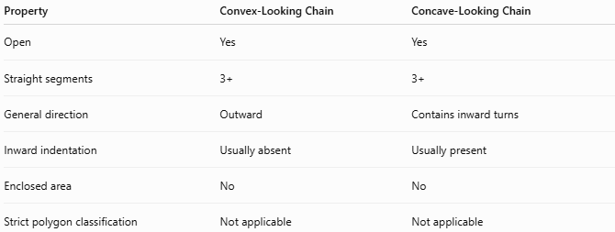
Property | Convex-Looking Chain | Concave-Looking Chain
Open | Yes | Yes
Straight segments | 3+ | 3+
General direction | Outward | Contains inward turns
Inward indentation | Usually absent | Usually present
Enclosed area | No | No
Strict polygon classification | Not applicable | Not applicable
The distinction is visual rather than a strict convex/concave polygon classification.

Convex-Looking Chain vs. Closed Convex Polygon
# Source: AI Source: Provided by: [Data Path: Persons Table -> ID Column: 1, Name_En Column: Motasem Essam] -> From: [ChatGPT] on [7/25/2026]
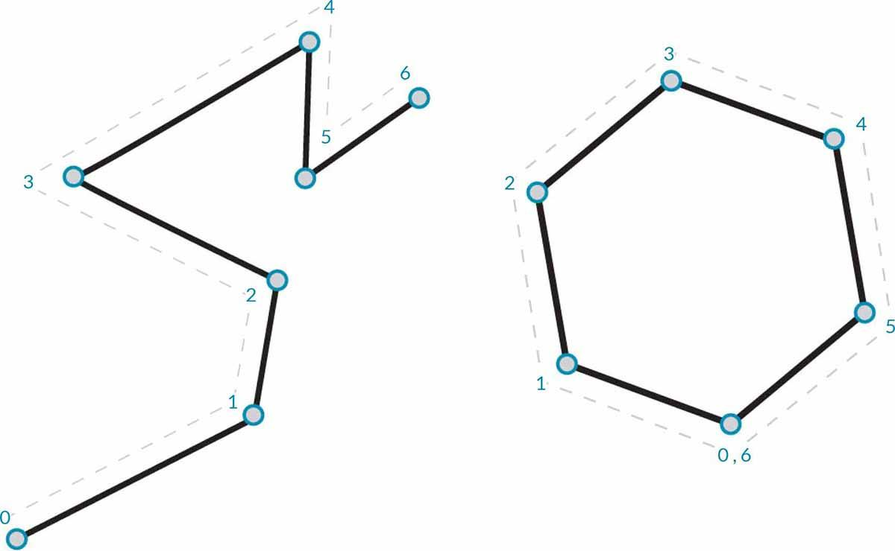
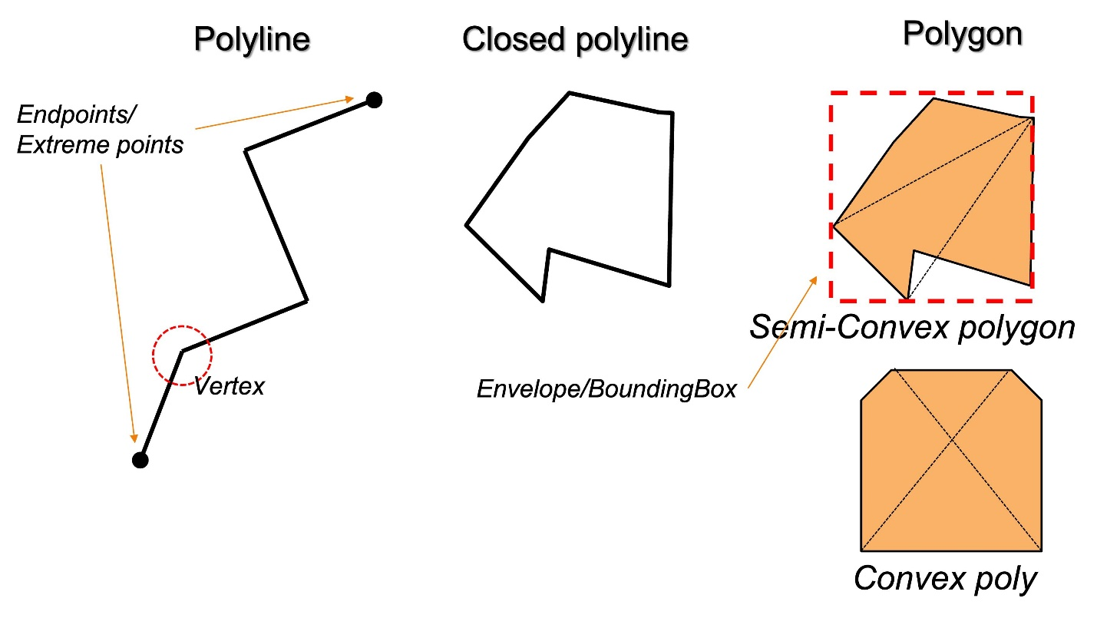
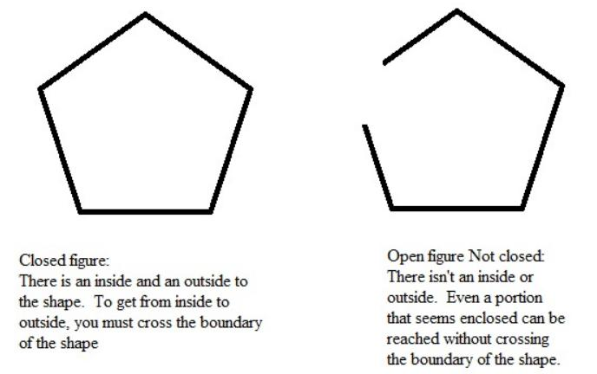
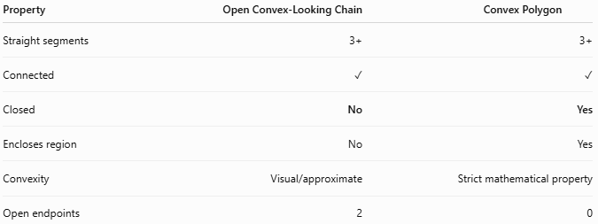
Property | Open Convex-Looking Chain | Convex Polygon
Straight segments | 3+ | 3+
Connected | ✓ | ✓
Closed | No | Yes
Encloses region | No | Yes
Convexity | Visual/approximate | Strict mathematical property
Open endpoints | 2 | 0
The most important difference is closure.

Area and Length
# Source: AI Source: Provided by: [Data Path: Persons Table -> ID Column: 1, Name_En Column: Motasem Essam] -> From: [ChatGPT] on [7/25/2026]
Area
Because the chain is open:
$$\boxed{\text{No enclosed area}}$$
Total Chain Length
For $n$ segments:
$$\boxed{L=L_{1}+L_{2}+⋯+L_{n}}$$

Key Points
# Source: AI Source: Provided by: [Data Path: Persons Table -> ID Column: 1, Name_En Column: Motasem Essam] -> From: [ChatGPT] on [7/25/2026]
An Open Convex-Looking Polygonal Chain is:
$$\boxed{\text{Open}+\text{3 or More Straight Segments}+\text{Generally Outward Turning}}$$
It:
- Has three or more straight segments.
- Has two open endpoints.
- Does not enclose an area.
- Generally turns in one consistent direction.
- Does not have obvious inward indentations.
- May be symmetric or asymmetric.
- May have equal or unequal segment lengths.
- Can be zigzag, stair-step, or arc-like.
- Is not technically a convex polygon because it is open.
Most important distinction
$$\boxed{\text{Convex-Looking Open Chain}≠\text{Convex Polygon}}$$
The first is an open polygonal path with an outward-turning appearance, while the second is a closed polygon satisfying the mathematical definition of convexity.

Conclusion
# Source: AI Source: Provided by: [Data Path: Persons Table -> ID Column: 1, Name_En Column: Motasem Essam] -> From: [ChatGPT] on [7/25/2026]
An Open Convex-Looking Polygonal Chain is an open chain of straight segments that generally bends outward without forming obvious inward indentations. It can be further classified according to its turning pattern, symmetry, segment lengths, and geometric arrangement. For mathematical precision, the term outward-turning open polygonal chain is preferable to calling it a "convex polygon," since convexity is normally defined for a closed set.

